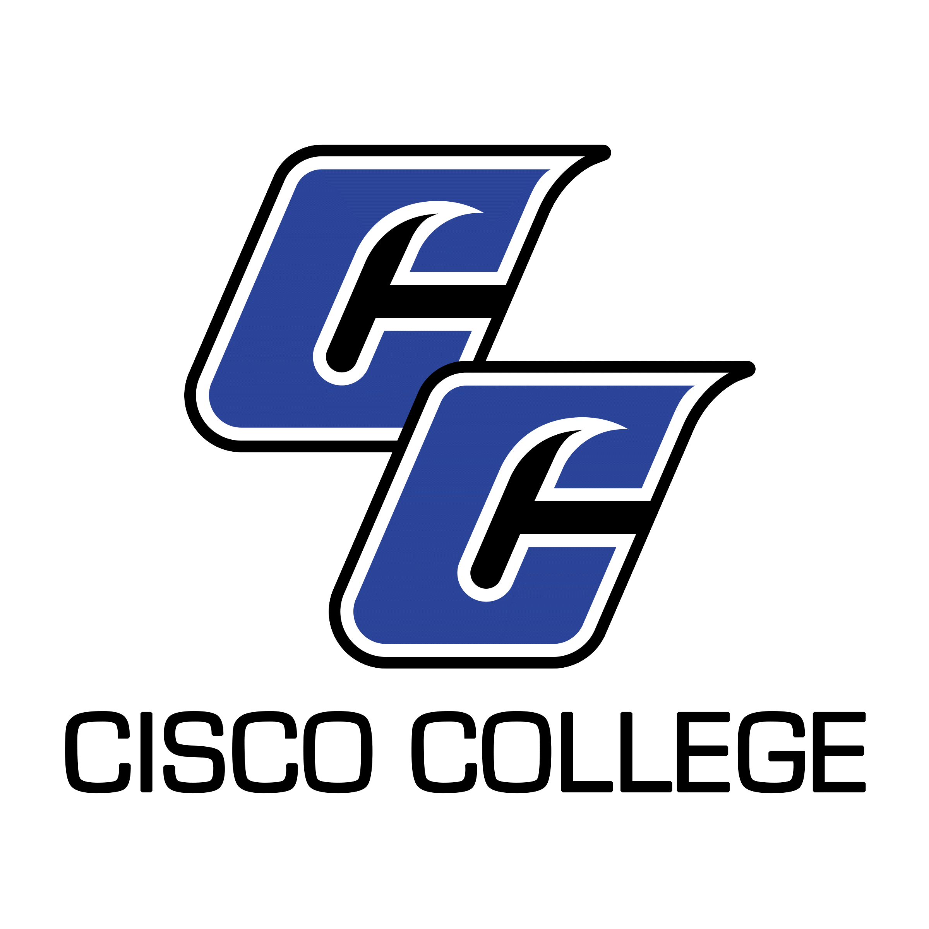

Job Posting
Professor of Welding Technology
Date Posted: November 2, 2020
End Date: Until Filled

Cisco College is currently accepting applications for the position of full-time Welding Professor in the Career & Technology Welding Program. Resume packages will be accepted until the position is filled. Applicants should have a combination of technical preparation from an accredited college or university, and work experience. This position requires applicants to have a minimum of 3 years work-related experience in the welding industry. The position is based at the Abilene Campus of Cisco College. However, courses may be taught on both campuses.

This position will report to the Division Chair of Industrial Technologies. The courses of study prepare students with the skills and knowledge required to gain employment in the welding industry. It is a full-time, 9-month position with benefits and will be posted until filled. Resume packages will be received via mail, fax, and email, but email is preferred.

CISCO COLLEGE offers a generous benefit package, including comprehensive medical, dental, and vision insurance. For the medical benefit only, member-only coverage along with $5,000 of basic term life is provided at no cost to the employee. Other coverages are selected by the employee and payment made through payroll deduction.
The benefits of working in higher education are many and allow you to plan well for your future. Cisco College offers retirement savings such as Teacher Retirement System or Option Retirement Plan – for qualified positions. Twelve month employees also receive both sick and vacation leave on a month to month basis.

Please note: A complete resume package must include a cover letter, completed and signed Cisco College Application (available on the “Employment” Page of our website at www.cisco.edu), resume or Curriculum Vitae, Teaching Philosophy and unofficial copy of transcript, to include any certifications or licensures. Please ensure all required documents are included with your submission. Incomplete packages will be returned unprocessed.

Please submit your resume package to:
Shelli Garrett
Director of Human Resources
Cisco College
101 College Heights
Cisco, Texas 76437
Office: 254-442-5121
Fax: 254-442-5100
shelli.garrett@cisco.edu

Cisco College is an Equal Opportunity Employer

Cisco College

Faculty Job Description (Professor)

Job Title: Professor

Reports to: Workforce Pathway Program Leader

Last Reviewed: 2/20/2020

Job Summary

The primary responsibility of this individual is to provide quality instruction to Cisco College students. Responsibilities may include teaching a variety of courses. Teaching courses through various mediums, teaching at a variety of locations and teaching a varied schedule of day and evening courses are also possibilities.

Faculty members at Cisco College are expected to accomplish assigned duties in an efficient, effective and competent manner, and to strive for improvement and excellence in all work performed. Additionally, faculty are asked to demonstrate a commitment to the comprehensive role of the community college as stated in the College Mission, and to cooperate and work harmoniously with College personnel and the public. All Cisco College employees are expected to follow College policies, rules, regulations, and guidelines that relate to the specific position.

Primary Duties

Provide quality learning experiences for students and maintain the integrity of course standards and objectives. Meet class punctually and keep class throughout the scheduled time as appropriate to provide quality learning experiences.

Follow the College’s guidelines for course syllabi and state clear learning objectives and assessment criteria. Assess student learning and provide consistent feedback to students for improvement.

Maintain five regular office hours per week designated as time available to assist students. Be available by appointment for additional hours according to student needs. Post hours on office door, clearly demonstrate availability and submit hours to supervisor.

Actively seek to stay current in the instructional discipline and in teaching and learning theory by participating in professional development. Follow through by making adjustments in delivery of courses to provide quality learning opportunities for students.

Support the mission of the College by serving on College committees, attending division and faculty meetings, and submitting all required paper work in a timely manner.

Participate in academic advising and registration with a positive attitude toward helping students. Stay current on advising policies.

Assist the Division Chair with divisional duties including but not limited to: scheduling, program planning, curriculum development, institutional effectiveness, assessment, catalog and website updates.

Complete all elements of the Faculty Evaluation Plan including having students evaluate courses and working with the Division Chair to establish goals and evaluate performance.

Participate actively in the College’s Institutional Effectiveness and Assessment of Student Learning Programs to develop a more effective learning environment for Cisco College students.

Cooperate and maintain professionalism with the Administration, Division Chairs, Faculty, Staff, and other members of the College community to facilitate the learning process.

Communicate clearly and effectively using the college network system, including e-mail, word processing, and the Campus Connect / FAS Module.

Represent the College in a professional manner to all constituencies and the general public.

Perform other related duties as assigned by the Division Chair and College Administration.

Minimum Qualifications

Credentials appropriate to the specific Academic Transfer, Developmental or Career and Technical Education position.

Effective verbal and written communication skills.

Preferred Additional Qualifications

Teaching experience at the college level.

Active participation in relevant professional activities and organizations.

