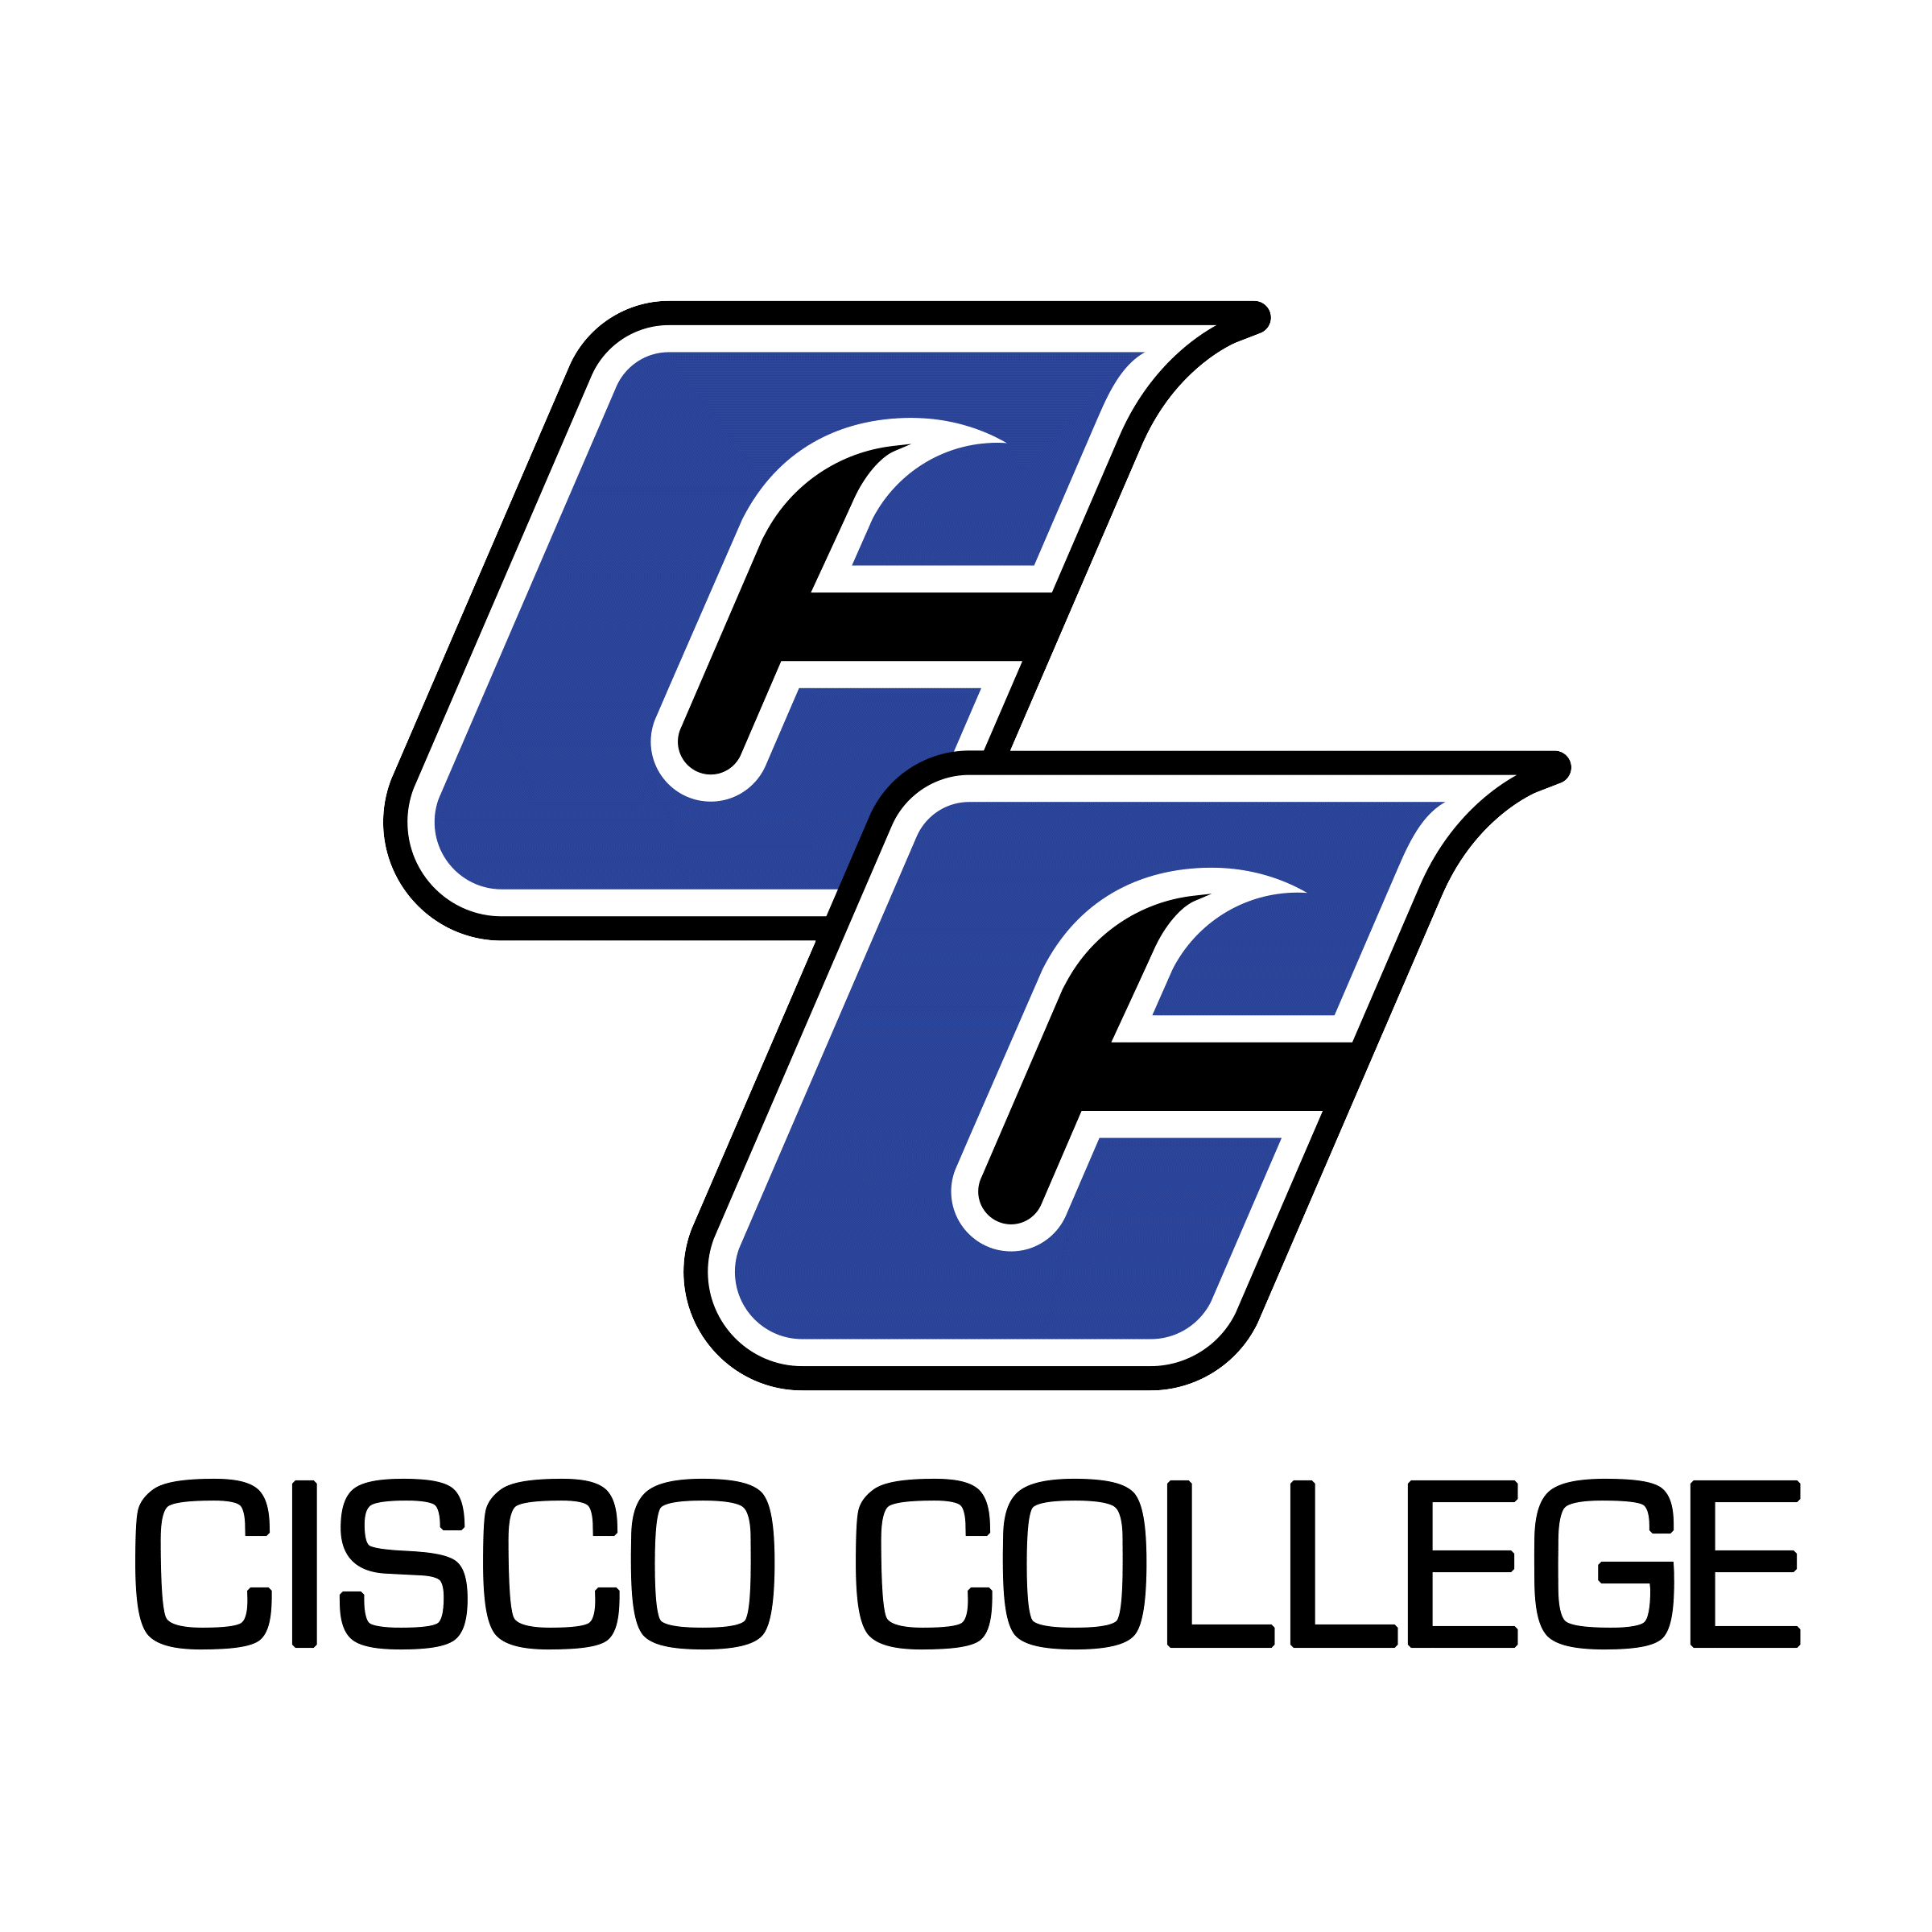

Job Posting
Welcome Center & Academic Support Specialist (Abilene)

Date of Posting: March 23, 2021
Posting End Date: Until Filled

Cisco College is accepting applications for an exciting opportunity as a Welcome Center & Academic Support Specialist. The position is based at our Abilene campus and requires a high school diploma/GED. The position is a full-time, 12-month position with benefits. Please scroll down for a detailed Job Description. Completed Staff Applications will be accepted until the position is filled. Resume packages are received via email, fax, and USPS, but email is preferred.

CISCO COLLEGE offers a generous benefit package, including comprehensive medical, dental, and vision insurance. For the medical benefit only, member-only coverage along with $5,000 of basic term life is provided at no cost to the employee. Other coverages are selected by the employee and payment made through payroll deduction.

The benefits of working in higher education are many and allow you to plan well for your future. Cisco College offers retirement savings such as Teacher Retirement System or Option Retirement Plan – for qualified positions. Twelve month employees also receive both sick and vacation leave on a month to month basis.

Please note: A complete resume package must include a cover letter, completed and signed Cisco College Application, resume, and transcript. (Cisco College Application is located on the “Human Resources” page of the website under "Employment" at www.cisco.edu.) Please ensure all required documents are included with your submission. Incomplete packages will be returned unprocessed.

Resume packages should be submitted to:

Shelli Garrett
Director of Human Resources
Cisco College
101 College Heights
Cisco, Texas 76437
Office: 254-442-5121
Fax: 254-442-5100
shelli.garrett@cisco.edu
Cisco College is an Equal Opportunity Employer

Cisco College
Job Description
Job Title: Welcome Center & Academic Support Specialist
Reports to: Director of Academic Support

Job Summary:
The Welcome Center & Academic Support specialist is primarily responsible for maintaining availability, organization, and information in the front desk area, and for providing support for new student cohorts. Responding to questions about the college, greeting and directing all students and visitors, and assisting students with enrollment, registration, and financial aid questions are priorities. The Welcome Center & Academic Support specialist maintains a broad understanding of the college by being knowledgeable about the college organization, campuses, programs, publications, services, and personnel.
The Welcome Center & Academic Support specialist is also responsible for focusing on on-boarding, outreach, and support for new students. Identifying a new student cohort each year, assisting new students through the admissions and enrollment process, guiding students to the appropriate pathway and counselor, and continued outreach to new students related to success, academic support, college resources and services, and the new student experience are priorities.
The Welcome Center specialist is expected to accomplish assigned duties in an efficient, effective, and competent manner, and to strive for improvement and excellence in all work performed. Additionally, Cisco College employees are asked to demonstrate a commitment to the comprehensive role of the community college as stated in the College Mission and to work harmoniously with College personnel and the public. All Cisco College personnel are expected to follow College policies, rules, regulations, and guidelines that relate to this position.
Primary Duties:
- Organizes and prioritizes operations of the Welcome Center. This includes checking student accounts, assisting with enrollment or registration processes, and providing support to student retention processes.
- Greets, assists, and directs students and visitors to appropriate offices, services, resources, or classrooms.
- Manages a student sign-in/scheduling software.
- Provides knowledgeable assistance to students with financial aid questions using the college's information and computer systems
- Answers calls to the general Abilene campus telephone number using a multi-line phone and directs calls as needed to appropriate offices.
- Responsible for delivery of mail, faxes, and other paperwork/materials.
- Responds to student and faculty questions.
- Responds appropriately to inquiries sent to General Questions college email.
- Communicates with identified students regarding support services and other resources to support student success and learning.
- Communicates with new college applicants by email or phone regarding admission and enrollment steps and processes, new student processes such as registration, and college services and resources to support student success and retention.
- Works with the Director of Academic Support to implement and evaluate processes, information, and programs and/or services for new student cohorts.
- Provides support to Counselors/Advisors and other academic support areas.
- Assists with campus tours for prospective students.
- Maintains copy machines and other general office items as needed.
- Assists with updating informational displays including documents and TVs in the front desk area and lobby.
- Performs other duties as assigned.
- Communicates regularly with the Director of Academic Support Services and assists the Director in reviewing the efficiency of the Welcome Center and updating or implementing customer service processes as needed.

Minimum Qualifications
- Excellent interpersonal skills and demonstrated professionalism.
- Excellent verbal and written communication skills.
- Excellent computer skills.
- Ability to gain new technological skills as may be required by changing technology.
- Ability to maintain confidentiality.
- Willingness to innovate and engage a varied student population, including communication and outreach in all formats, individually and in groups.

Preferred Qualifications
- Associate Degree or experience in a business or educational setting.

