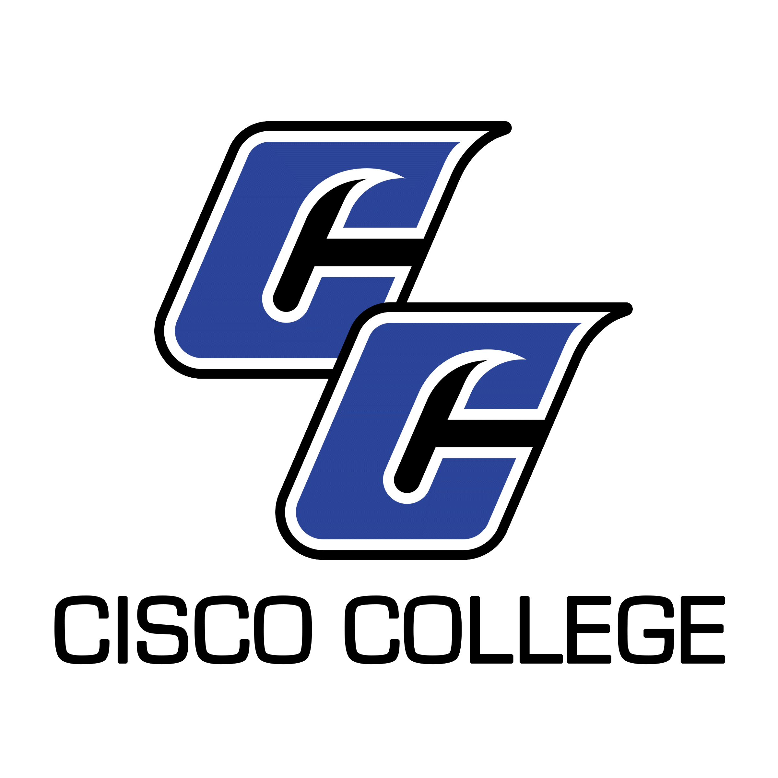

Job Posting

Part-Time Distance Education Specialist (Abilene Campus)

Date Posted: June 5, 2020
Posting End Date: Until Filled

Cisco College is accepting applications for the position of Part-Time Distance Education Specialist. Minimum qualifications for this position include a high school diploma and excellent organization, communication, and technology skills. The position reports to the Director of Distance Education. Applicants may not be enrolled at Cisco College. Travel between Abilene and Cisco may be required. Please review the full Job Description for more details. Applications will be accepted until the position is filled.

Please note: Applications will be accepted via e-mail, fax, or USPS, (e-mail is preferred) and should be submitted to:

Shelli Garrett
Director of Human Resources
Cisco College
101 College Heights
Cisco, Texas 76437
Office: 254-442-5121
Fax: 254-442-5100
shelli.garrett@cisco.edu

Cisco College is an Equal Opportunity Employer

Cisco College
Job Description

Job Title: Part-Time Distance Education Specialist

Reports to: Director of Distance Education

Classification: Part-time (Maximum 18 hours per week)

Job Summary
This position supports the Director of Distance Education. Primary responsibilities include assisting with the College’s Learning Management System (Canvas) and video conferencing equipment, along with performing clerical duties. The Distance Education Specialist will work closely with students, faculty, and staff. Sensitive and confidential material is managed by this position, and strict confidentiality is required.

All Cisco College, employees are expected to accomplish assigned duties in an efficient, effective and competent manner and to strive for improvement and excellence in all work performed. Additionally, all employees are asked to cooperate and work harmoniously with College personnel and the public. All Cisco College employees are expected to follow College policies, rules, regulations, and guidelines that relate to the specific position.

Primary Duties
- Assist the Director of Distance Education in accomplishing program policies and procedures
- Respond to student, faculty, and staff questions via phone, email, and in-person
- Perform LMS admin duties
- Troubleshoot video conferencing equipment and communicate with the Information Technology Office
- Process enrollment requests for the Digital Higher Education Consortium of Texas (formerly the Virtual College of Texas)
- Be knowledgeable about Distance Education course and degree offerings
- Perform other duties as assigned

Minimum Qualifications
- High School Diploma required, Associate’s Degree preferred
- Excellent verbal and written communication skills
- Ability to work well with students, faculty, and staff
- Excellent computer application skills and a high comfort level with technology
- Ability to gain new skills as may be required by changing technology
- Ability to maintain confidentiality
- Access to a reliable Internet connection at home for occasional weekend and/or evening LMS admin duties
- Ability to travel between Abilene and Cisco as needed

