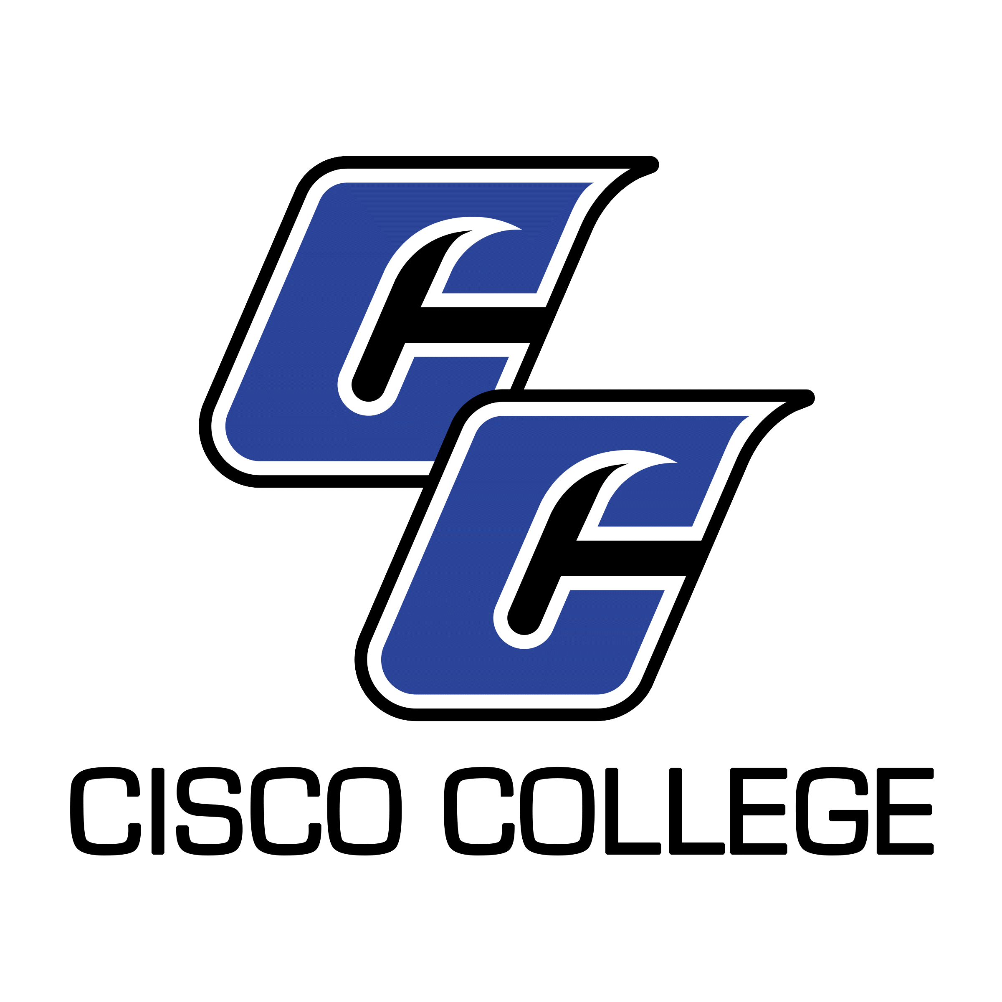

Job Posting
Executive Director of Information Technology

Date Posted: February 25, 2021
End Date: Until Filled

Cisco College is accepting resume packages for the position of Executive Director of Information Technology. The Executive Director of Information Technology oversees all Information Technology (IT) functions within the institution. The Executive Director is responsible for planning, personnel, maintenance, development, installation, training and budget management of all aspects of college technology. In addition, this position coordinates the use of technology in the instructional settings throughout the college under the direction of the Vice President of Instruction. This position assists the President in formulating policy, developing budgets, training personnel, and developing programs related to the use of technology College-wide.

This position requires a Bachelor’s degree. A Master’s degree is preferred. Additional qualifications include excellent written and verbal communication skills, excellent computer skills, with documented experience in developing, organizing, managing budgets, and successfully implementing new programs, projects, services, or curriculum. The Executive Director of Information Technology should possess proven experience working with information technology hardware and software. (Please scroll down to review the attached Job Description.) The position will be primarily based on the Cisco campus. However, it will require regular travel between Cisco and Abilene, with a working space in both places. The position is a full-time, 12 month position with benefits. Resume packages will be accepted until the position is filled. Candidates may be asked to provide examples of brochures, flyers, newsletters, etc., as evidence of design capabilities and experience. Resume packages will be received via email, US Mail, and fax, but email is preferred.
CISCO COLLEGE offers a generous benefit package, including comprehensive medical, dental, and vision insurance. For the medical benefit only, member-only coverage along with $5,000 of basic term life is provided at no cost to the employee. Other coverages are selected by the employee and payment made through payroll deduction.
The benefits of working in higher education are many and allow you to plan well for your future. Cisco College offers retirement savings such as Teacher Retirement System or Option Retirement Plan – for qualified positions. Twelve month employees also receive both sick and vacation leave on a month to month basis.
Please note: A complete resume package must include a cover letter, completed Cisco College Application (available on the Employment Page of the college website at www.cisco.edu), resume or Curriculum Vitae (CV), and unofficial copies of transcripts. Please ensure you include all required documents with your submission. Incomplete packages will be returned unprocessed.

Resume packages should be submitted to:

Shelli Garrett
Director of Human Resources
Cisco College
101 College Heights
Cisco, Texas 76437
254-442-5121
shelli.garrett@cisco.edu

Cisco College is an Equal Opportunity Employer

Cisco College

Job Description

Job Title: Executive Director of Information Technology

Reports to: President of the College

Updated: February 2021

Job Summary

The Executive Director of Information Technology oversees all Information Technology (IT) functions within the institution. The Executive Director is responsible for planning, personnel, maintenance, development, installation, training and budget management of all aspects of college technology. In addition, this position coordinates the use of technology in the instructional settings throughout the college under the direction of the Vice President of Instruction. This position assists the President in formulating policy, developing budgets, training personnel, and developing programs related to the use of technology College-wide.

It is expected that the Executive Director of Information Technology will accomplish assigned duties in an efficient, effective, and competent manner, and will strive for improvement and excellence in all work performed. Additionally, this individual must demonstrate a commitment to the comprehensive role of the community college as described in the Cisco College mission statement. The Executive Director must cooperate and work harmoniously with college personnel and the public, and must follow all college policies, rules, regulations and guidelines as they relate to this position.

Primary Duties

Provide leadership for IT throughout the college.

Keep the President of the college apprised of all issues and activities related to IT at Cisco College.

Stay abreast of current IT hardware and software, informing the college President as needed.

Stay abreast of current IT policy, laws and rules originating outside the college, informing the college President as needed.

Make recommendations for use and acquisition of IT resources for the improvement or expansion of internal operations college-wide.

Coordinate with external IT contractors.

Oversee the management of SharePoint (the college’s intranet).

Develop and keep current an IT strategic and institutional effectiveness plans to help guide the college in technology needs, staffing needs, and implementation procedures.

Work with the Vice President of Instruction, and, as directed, the deans and division chairs to help oversee all faculty technology needs.

Oversee the IT budgets, make recommendations regarding the annual budget, and effectively manage the College’s IT resources.

Provide IT information and assistance for other college departments, as requested.

Serve as a resource person for the public concerning IT.

Oversee, develop, and maintain an inventory of all assigned IT equipment.

Keep abreast of professional development in IT by attending conferences, taking online classes, and reading appropriate professional literature.

Other duties as assigned by the President.

Minimum Qualifications

Three years of experience in a position with leadership responsibilities, preferably in college-level programs.

Documented experience in developing, organizing, and successfully implementing new programs, projects, or curriculum.

Experience working with information technology hardware and software.

Excellent written and verbal communication skills.

Excellent computer skills.

Bachelor’s Degree in related field

For candidates who do not meet the minimum qualifications, a combination of education and experience providing comparable knowledge and abilities will be considered.

Preferred Qualifications

Five years of administrative experience.

Master’s degree.

