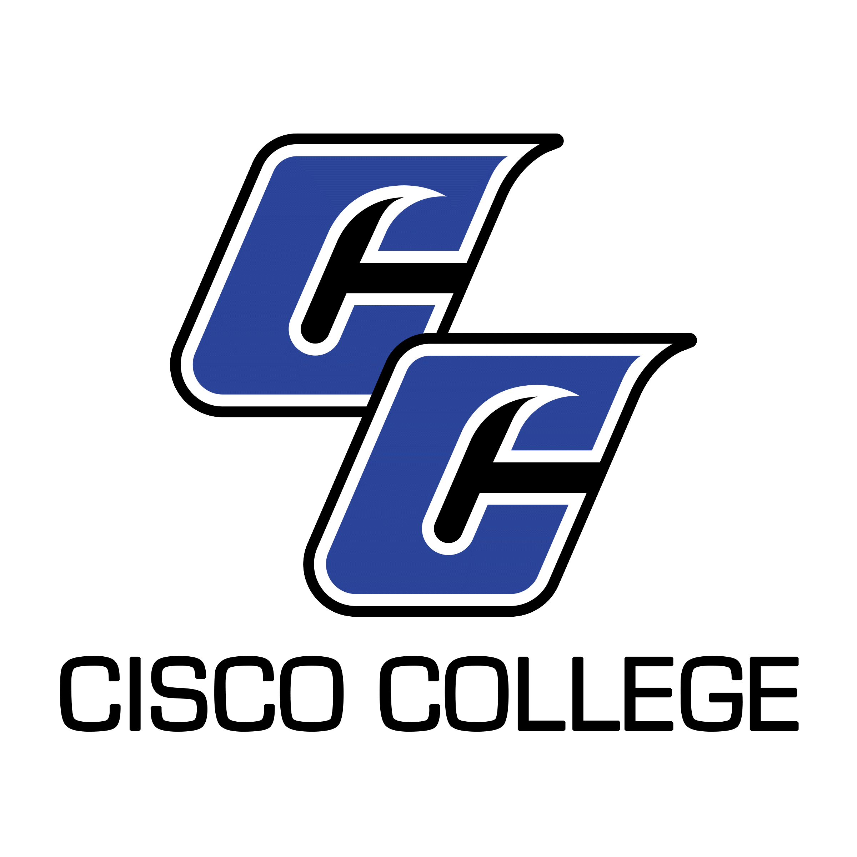

Job Posting
Assistant Football Coach

Date Posted: May 21, 2019
Posting End Date: Until Filled

Cisco College is accepting resume packages for the position of Assistant Football Coach (Cisco Campus). Primary responsibilities of the Assistant Football Coach are to assist the Head Football Coach with the organization and implementation of all aspects of the football program. A minimum of a Bachelor’s Degree from a regionally-accreditated institution is required. Preferred qualifications include a Master’s Degree, experience coaching football at the college level, and knowledge of NJCAA rules and regulations. Resume packages will be accepted until the position is filled.

CISCO COLLEGE offers a generous benefit package, including comprehensive medical, dental, and vision insurance. For the medical benefit only, member-only coverage along with $5,000 of basic term life is provided at no cost to the employee. Other coverages are selected by the employee and payment made through payroll deduction.

The benefits of working in higher education are many and allow you to plan well for your future. Cisco College offers retirement savings such as Teacher Retirement System or Optional Retirement Plan – for qualified positions. Twelve month employees also receive both sick and vacation leave on a month to month basis.

Please note: A complete resume package must include a cover letter, completed and signed Cisco College Application (available on the “Employment” Page of our website at www.cisco.edu), CV or resume, Philosophy of Education, and unofficial copy of transcripts. Please ensure all required documents are included with your submission. Incomplete packages will be returned unprocessed.

Resume Packages will be accepted via mail, fax, and email (preferred) and should be submitted to:

Shelli Garrett
Director of Human Resources
Cisco College
101 College Heights
Cisco, Texas 76437
Office: 254-442-5121
Fax: 254-442-5100
shelli.garrett@cisco.edu
Cisco College is an Equal Opportunity Employer

Cisco College

Job Description

Job Title: Assistant Football Coach

Reports to: Head Football Coach

Classification: Programatic

Last Updated: May 15, 2019

Job Summary

The primary responsibilities of the Assistant Football Coach at Cisco College are to assist the Head Football Coach with the organization and implementation of all aspects of the football program. General duties consist of developing and improving athletic opportunities for football student-athletes; examining, researching, and making recommendations for improving the current football program; selection and evaluation of football student-athletes; adhere to a recruiting strategy that fits with the Cisco College philosophy for student recruitment; and developing a cooperative working environment with the faculty and other departments of the College.

A commitment to the comprehensive role of the community college as stated in the College Mission will be demonstrated through contributions to the College such as advising, committee work, and collaborating with faculty to encourage student success. Cooperation and working harmoniously with College and School District personnel and the public are imperative for the success of the football program. The Assistant Football Coach is expected to accomplish assigned duties in an efficient, effective and competent manner, and to strive for improvement and excellence in all work performed. All Cisco College employees are expected to follow College policies, rules, regulations, and guidelines that relate to the specific position.

Primary Duties

Coordinates defense/special team and assists with all phases of the football program as assigned by the Head Football Coach.

Recruitment of student football athletes in accordance with the NJCAA rules and regulations.

Coordinates strategic aspects of the football program. Prepares, and conducts individual and team practices, training, and conditioning.

Manages the purchase of all football equipment, the care of equipment and facilities, and the reconditioning of equipment.

Assist the Head Football Coach promoting the College through contact with local businesses, civic groups, boosters, alumni, high schools, and other colleges and universities.

Develop relationships with other football programs in order to facilitate opportunities for our football student-athletes.

Adheres to compliance with NJCAA rules and regulations, as well as conference rules and regulations, governing the football program.

Develop and maintain a congenial working relationship with the faculty in order to improve student learning by encouraging academics as a priority for football student-athletes.

Communicate clearly and effectively using the College’s network.

Teach assigned cources within the Kinesiology Department.

Performs other duties as assigned.

Minimum Qualifications

Experience coaching football at the college level.

Excellent organizational skills.

Knowledge of NJCAA rules and regulations.

Ability to communicate effectively, both orally and in writing.

Ability to foster a cooperative work environment.

Bachelor’s Degree from a regionally-accredited institution.

For candidates who do not meet the minimum qualifications, a combination of education and experience providing comparable knowledge and abilities will be considered.

Preferred Additional Qualifications

Master’s Degree

Teaching experience at the college level.

Active participation in relevant professional activities and organizations.

