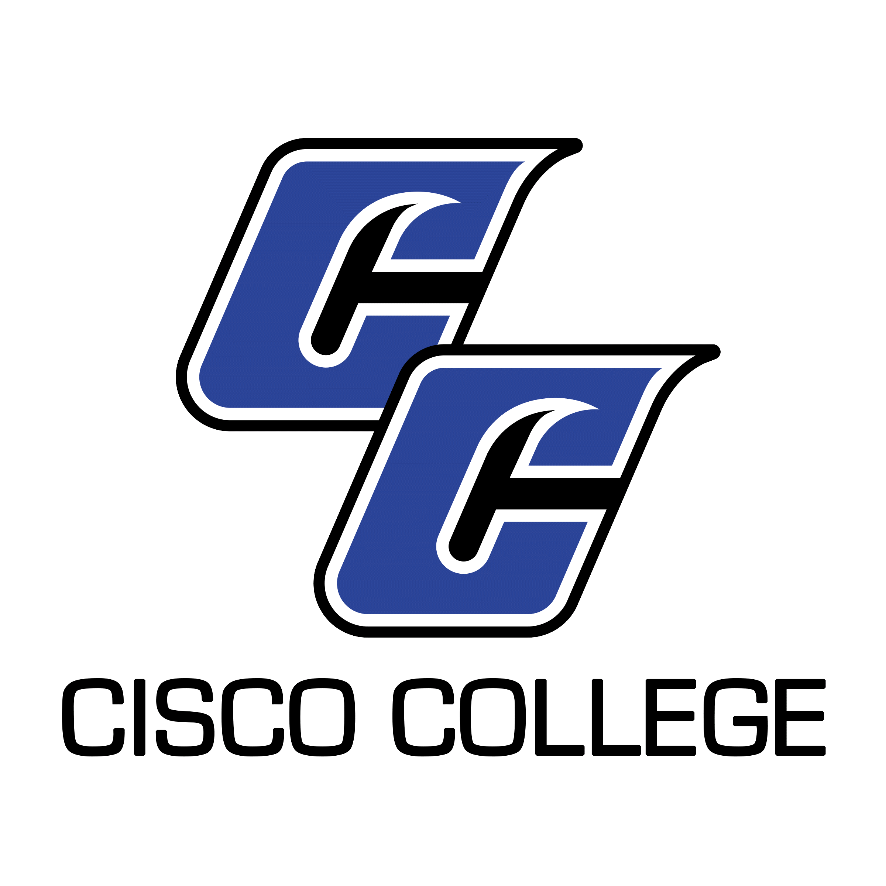
Job Posting
Art Professor (Tenure-track)

Date Posted: April 19, 2021
End Date: Until Filled

Cisco College is accepting resume packages for the position of Art Professor (tenure-track). A minimum education requirement for this position is a Master’s Degree with 18 graduate hours in Art. An applicant must possess and exhibit expertise in teaching studio art, and have teaching experience preferably in a community college setting or equivalent. (Please scroll down to review the complete job description.) The position will require teaching at a variety of locations, and teaching a varied schedule of day and evening courses may also be required. This is a 9-month contract position.

CISCO COLLEGE offers a generous benefit package, including comprehensive medical, dental, and vision insurance. For the medical benefit only, member-only coverage along with $5,000 of basic term life is provided at no cost to the employee. Other coverages are selected by the employee and payment made through payroll deduction.

The benefits of working in higher education are many and allow you to plan well for your future. Cisco College offers retirement savings such as Teacher Retirement System or Option Retirement Plan – for qualified positions. Twelve month employees also receive both sick and vacation leave on a month to month basis.

Please note: A complete resume package must include a cover letter, completed Cisco College Application, resume, philosophy of education, and unofficial copies of transcript(s). Please ensure all required documents are included with your submission. Thank you!

Resume packages may be submitted (via email, fax, or USPS, but email is preferred) to:

Shelli Garrett
Director of Human Resources
Cisco College
101 College Heights
Cisco, Texas 79437
Office: 254-442-5121
Fax: 254-442-5100
shelli.garrett@cisco.edu

Cisco College is an Equal Opportunity Employer

Cisco College

Job Description

Job Title: Art Professor (Tenured)

Reports to: Division Chair

Job Summary

The primary responsibility of this individual is to provide quality instruction to Cisco College students in Cisco and in Abilene. This individual’s responsibilities will primarily consist of teaching Art Appreciation courses in a variety of formats, along with the opportunity to teach Studio Art classes such as design, drawing, painting, sculpture, and digital art. Teaching courses over a distance education medium, teaching at a variety of locations, and teaching a varied schedule of day and evening courses may also be required.

Faculty members at Cisco College are expected to accomplish assigned duties in an efficient, effective and competent manner, and to strive for improvement and excellence in all work performed. Additionally, faculty are asked to demonstrate a commitment to the comprehensive role of the community college as stated in the College Mission, and to cooperate and work harmoniously with College personnel and the public. All Cisco College employees are expected to follow College policies, rules, regulations, and guidelines that relate to the specific position.

Primary Duties

Provide quality learning experiences for students and maintain the integrity of course standards and objectives. Meet class punctually and keep class throughout the scheduled time as appropriate to provide quality learning experiences.

Follow the College’s guidelines for course syllabi and state clear learning objectives and assessment criteria. Assess student learning and provide consistent feedback to students for improvement.

Maintain five regular office hours per week designated as time available to assist students. Be available by appointment for additional hours according to student needs. Post hours on office door, clearly demonstrate availability and submit hours to supervisor.

Actively seek to stay current in the instructional discipline and in teaching and learning theory by participating in professional development. Follow through by making adjustments in delivery of courses to provide quality learning opportunities for students.

Support the mission of the College by serving on College committees, attending division and faculty meetings, and submitting all required paper work in a timely manner.

Participate in academic advising and registration with a positive attitude toward helping students. Stay current on advising policies.

Assist the Chair with divisional duties including but not limited to: scheduling, program planning, and curriculum and catalog development.

Complete all elements of the Faculty Evaluation Plan including having students evaluate courses and working with the Division Chair to establish goals and evaluate performance.

Participate actively in the College’s Institutional Effectiveness and Assessment of Student Learning Programs to develop a more effective learning environment for Cisco College students.

Cooperate and maintain professionalism with the Administration, Division Chairs, Faculty, Staff, and other members of the College community to facilitate the learning process.

Communicate clearly and effectively using the college network system, including e-mail, word processing, and the Campus Connect / FAS Module.

Represent the College in a professional manner to all constituencies and the general public.

Perform other related duties as assigned by the Division Chair and College Administration.

Minimum Qualifications

Master’s Degree and a minimum of 18 graduate hours in Art.

Effective verbal and written communication skills.

Preferred Additional Qualifications

Teaching experience at the college level.

Online teaching experience.

Active participation in relevant professional activities and organizations.

